PARTICIPANTS: The Center is non-denominational and serves all people aged 60 or older that live within the City of Alexandria.

NEW PARTICIPANT REGISTRATION: A short registration process is used to assess a prospective participant’s needs and to meet Administrative requirements. Please call 703-751-2766 to make an appointment.

SENIOR OPPORTUNITIES: The Center promotes happiness and independence through health and wellness, social, educational, recreational, and cultural opportunities. Referrals are made to other services throughout the community. Nutritious lunches are served daily.

CENTER LOCATION: The Center is located at 4650 Taney Avenue, Alexandria, across the street from the Patrick Henry Elementary School and Rec Center. Take Seminary Road to North Jordan then turn right on Taney Avenue.

TRANSPORTATION AND MEALS: The City of Alexandria provides door-to-door bus transportation and daily lunch. Registered participants can make bus or meal reservations by calling 703-751-2766, one day in advance before 11:00 am.

PARTNERS OF ST. MARTIN DE PORRES SENIOR CENTER: This senior center is a partnership funded by the City of Alexandria Department of Community and Human Services Division of Aging and Adult Services.

HELPFUL INFORMATION SOURCES:
- City of Alexandria Division of Aging and Adult Services: 703-746-5999
- Alexandria DOT Transportation: 703-746-4079
- Alexandria Meals-On-Wheels: 703-836-4414 x.110 Marshall Hespe
- Alexandria Senior Taxi: 703-746-5999 x1
- Arlington County Agency on Aging: 703-228-1700
- Fairfax Area Agency on Aging: 703-324-7948
- Legal Services of Northern Virginia: 703-778-6800 Mon-Thurs 9:30-12:30, 1:30-3:30
- Catholic Charities Emergency Assistance: 703-548-4227, 703-548-4881
- Catholic Charities Diocese of Arlington Senior Services: 703-751-2766

ST. MARTIN DE PORRES SENIOR CENTER STAFF:
Juanita Balenger, Senior Center Program Director
Luis Angel, Senior Center Assistant Director
Maria Mellor, Activities and Food Service Assistant, Volunteer Coordinator
Christine Simon, Operations Assistant

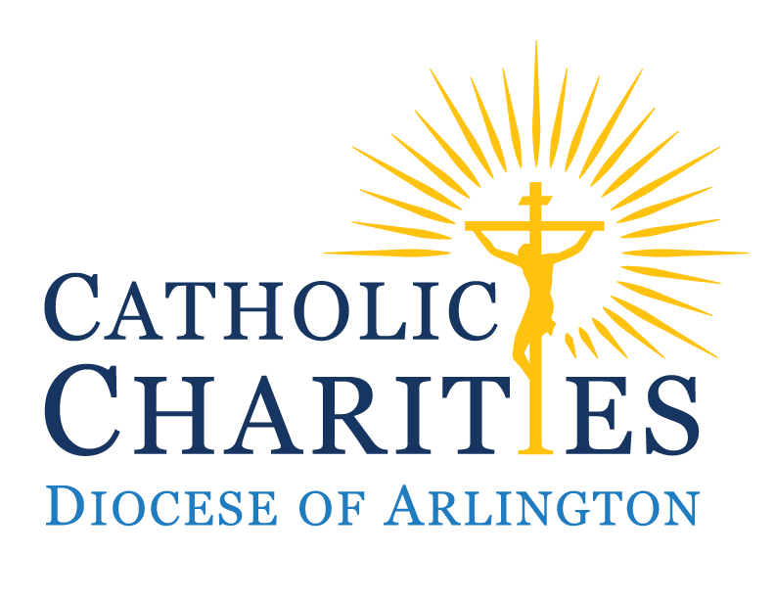

ST. MARTIN DE PORRES

SENIOR CENTER
ALL SENIORS WELCOME!
Welcome Back!!
This senior center is a partnership funded by the City of Alexandria Department of Community and Human Services Division of Aging and Adult Services.



January 2026

4650 Taney Ave. Alexandria, VA 22304
Phone: 703-751-2766
www.ccda.net/seniorservices/
CENTER OPEN: MONDAY – FRIDAY
8:45 A.M. – 1:30 P.M.
OFFICE HOURS: 8:30 A.M. – 4:30 P.M.

FIELD TRIPS

Wednesday, January 28: National Portrait Gallery
The National Portrait Gallery’s collections focus on images of American artists, politicians, scientists, inventors, activists, and performers who have contributed to the nation's history, development, and culture. Along with the Smithsonian American Art Museum, the museum is housed in the historic Old Patent Office Building. Lunch will be at the senior center. Seating on the bus is limited to 24 seats, open on a first come first serve basis. Bus pick up begins at 8:30am and we will be leaving the center at 9:30. Last day to sign up is January 27th at 11:30am. Please sign up with Maria in person while she is in her office to reserve your spot and pay.

**Reminders**
Additional Closures:
January 1 New Years Day
January 2 New Years Day
January 9 Staff Training Day
January 19 Martin Luther King Jr. Day
-Bus reservations must be made at least one day in advance by 11 am.

-Lunch reservations must be made at least one day in advance by 11am.

Happy Birthday!
January Birthdays!
Elizabeth Tunks – 2
Gerald Moore – 5
Aberash Woldeyes – 7
Antonia Lacaze – 9
Tesfamariam Bokurezion – 12
Linda Randall – 23
Vaso Lamprakaki – 23
Susan Picerno – 28
Manijeh Mojahed – 29
JB Barnes – 31

Our Birthday Party will be on Wednesday, January 21. Hope you are ready to dance and celebrate!!



